**Excercice**:  
NewAge Pharmaceuticals produces the drug NasaMist from four chemicals. Today, the company must produce 5000 pounds of the drug. The three active ingredients in NasaMist are A, B, and C. By weight, at least 7% of NasaMist must consist of A, at least 5% must consist of B, and at least 3% must consist of C. The cost per pound of each chemical and the amount of each active ingredient in one pound of each chemical are given in the file **P04_48.xlsx**. At least 600 pounds of chemical 3 must be used.

**My scenario:**

For a charity event, the French bakery decides to produce its famous chocolate cake, called Fondant aux Chocolats, composed of 4different chocolates. With the importance of this event, the bakery knows that it can sell as much as it produces. Hence, the employ will cook its maximum so an equivalent of 500pounds of Fondant aux Chocolats. Its creation is worldwide famous because the baker follows methodically the recipe. The secret of this cake is the range of components that are sugar, praline, and yeast. By weight, between 40 to 60% of the cake must consist of cacao, at least 15% and maximum 30% must consist of yeast, and , and a range of 10 to 20% of sugar. The cost per pound for each nutriment. Finally, at least 60 pounds of chocolate4 must be used and 10pounds for the others.

**Parameters:**

Chocolate: i ϵ {1,2,3,4}, Ingredient: c ϵ {1,2,3}

Ci: Cost per chocolat i

Mij: quantity of molecule c perchocolate i

D: Total production demand

Rc: minimun requirement of each ingredient c

Ac : maximum requirement of each ingredient c

Ni : minimun quantity for chocolatsi

**Decision:**

Xi: Unit of chocolate i to use for the cake

**Objectif:**

$$\min_{x_{i}}{\sum_{i}{c_{i}x_{i}}}$$

**Constraint:**

1. Σ Xi ≥ 0, (non negative constraint)
2. Xi ≥ D (the production must be equal or superior to the demand)
3. Xi ≥ Ni (the cake require a minimiun of chocolats i)
4. Mij ≥ Rc (require minimum amout of ingredients)
5. Mij ≤ Ac (require maximum amout of ingredients)

**Excel application:**

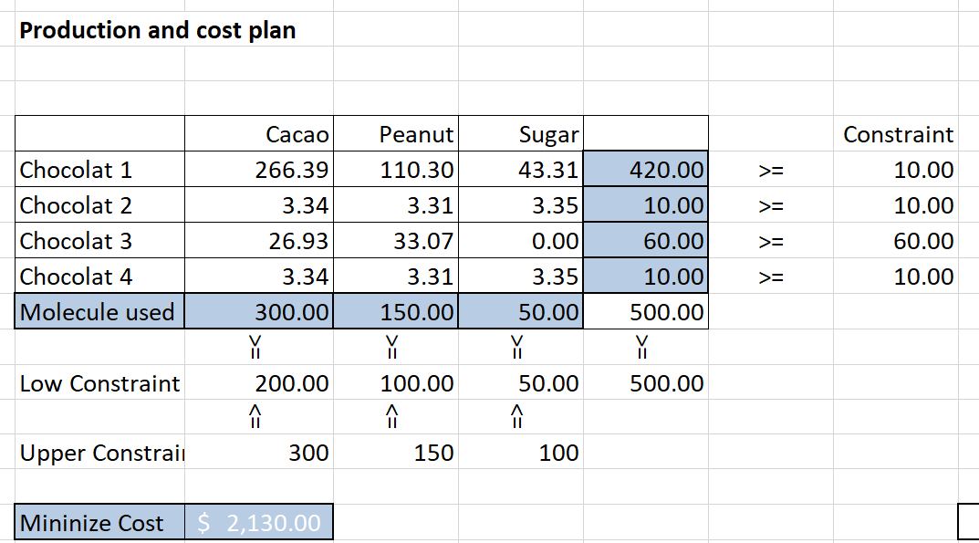

The final cost for the bakery will be $2,130.00. As the objective is to minimize the cost, most of the investment is in the chocolat1, explaining by its cheapest cost. Concerning the other chocolates, they only respect the requirement. Finally, Cacao and Peanut are exploited at the maximum of their capacities. On the other hand, the bakery restricted the amount of sugar.